ENTERTAINMENT INDUSTRY ANALYTICS DASHBOARD
ENTERTAINMENT INDUSTRY ANALYTICS DASHBOARD

Analysis of Movie Revenue,Ratings and Genre Trends(1990-2023)

Submitted By- Harsh Narain
Batch- Almax-prox-55
Dataset: Movie_Production_Details.xlsx,Movie_Revenue_and_Ratings.xlsx

SECTION 1: Project Overview

1.1 Business Context
The movie industry invests millions of dollars into each film, but not every movie becomes a hit. Studios want to understand which kinds of movies are most profitable, how budget and revenue relate, and how audience ratings vary across genres, languages, and age certifications.
In this project, I worked as a data analyst at BigScreen Insights, using two datasets – Movie Production Details and Movie Revenue & Ratings – to explore both financial performance and audience behaviour for films released between 1990 and 2023.

1.2 Objective
The objective of this project is to:
- Clean and merge the two movie datasets in Power BI.
- Build calculated columns and DAX measures for profit, ROI, genre performance and trend analysis.
- Design an interactive, multi-page Power BI dashboard with:
  - Financial Analysis page
  - Audience Rating page
  - Genre Analysis page
  - Side-by-side Movie Comparison page
- Answer the analytical questions given in the assignment (Q1–Q24) and summarise which genres, directors and strategies are most successful.

SECTION 2- Data Preparation

Power BI LINK: https://drive.google.com/file/d/1Wl284aMYW8WbueW-Q5MsTmus3CcZAxY0/view?usp=sharing

2.1 Data Import and Model
- Imported both Excel files into Power BI Desktop.
- Used Movie ID as the key to merge the tables into a single fact table called Movies_Final.
- Checked data types and changed:
  - Release Year, Runtime (Minutes), Budget (Millions), Worldwide Gross (Millions), etc. → Whole/Decimal Number
  - Release Month → Text
  - Title, Director, Genre, Language, MPAA Rating → Text

2.2 Data Cleaning (Power Query)
Key cleaning steps:
- Missing years:
  - Removed ~60 rows where Release Year was null (no reliable time information).
- Invalid release months:
  - In Release Month, removed weird values like "555&&", "-999" and blanks, keeping only valid month names.
- Nulls in revenue columns:
  - Checked Domestic Gross (Millions) & Opening Weekend Gross (Millions) for nulls. Kept only rows where financials were usable for analysis.
- MPAA Rating:
  - Replaced missing ratings with “Not Rated”.
- Removed extra columns that were not needed for analysis.

2.3 Key Calculated Columns
Created in Data View with DAX:
1: Profit(Millions)
Profit = VAR ww=Movies_Final[Worldwide Gross (Millions)]
VAR bd=Movies_Final[Budget (Millions)]
RETURN IF( OR(ISBLANK(ww),ISBLANK(bd)),BLANK(),ww-bd)
2: Production_Scale
Production_Scale = SWITCH(TRUE(),'Movies_Final'[Budget (Millions)]<20,"Indie",'Movies_Final'[Budget (Millions)]>=20 && 'Movies_Final'[Budget (Millions)]<=100,"Mid-Range",'Movies_Final'[Budget (Millions)]>100,"Blockbuster","Unknown")
3: Rating Bucket for IMDb
Rating Bucket = SWITCH(TRUE(),Movies_Final[IMDb Rating]<5,"Below 5",Movies_Final[IMDb Rating]<7,"5-7",Movies_Final[IMDb Rating]<9,"7-9",Movies_Final[IMDb Rating]>=9,"9+","Unknown")
4:Worldwide ROI and Domestic ROI
Worldwide ROI = DIVIDE(Movies_Final[Worldwide Gross (Millions)]-Movies_Final[Budget (Millions)],Movies_Final[Budget (Millions)] )
Domestic ROI = DIVIDE(Movies_Final[Domestic Gross (Millions)]-Movies_Final[Budget (Millions)],Movies_Final[Budget (Millions)])

5: Theme_Extracted from synopsis
Themes_Extracted =
VAR s = LOWER('Movies_Final'[Synopsis])

VAR sciFi = CONTAINSSTRING(s, "futuristic") || CONTAINSSTRING(s,"space") || CONTAINSSTRING(s,"planet")
VAR adventure = CONTAINSSTRING(s,"journey") || CONTAINSSTRING(s,"adventure")
VAR epic = CONTAINSSTRING(s,"epic")
VAR historical = CONTAINSSTRING(s,"historical")
VAR war = CONTAINSSTRING(s,"war") || CONTAINSSTRING(s,"battle")
VAR mythology = CONTAINSSTRING(s,"mythical") || CONTAINSSTRING(s,"ancient")
VAR psychological = CONTAINSSTRING(s,"psychological")
VAR social = CONTAINSSTRING(s,"freedom") || CONTAINSSTRING(s,"community")
VAR family = CONTAINSSTRING(s,"heartwarming")

VAR result =
IF(sciFi, "Sci-Fi; ", "") &
IF(adventure, "Adventure; ", "") &
IF(epic, "Epic; ", "") &
IF(historical, "Historical; ", "") &
IF(war, "War; ", "") &
IF(mythology, "Mythology/Fantasy; ", "") &
IF(psychological, "Psychological; ", "") &
IF(social, "Social; ", "") &
IF(family, "Family/Emotional; ", "")

RETURN
IF(result = "", "Other", LEFT(result, LEN(result) - 2))

6-Trendsetter Column
Trendsetter_Label Column =
IF( [Trendsetter Flag] = 1, "Trendsetter", "Normal" )

2.4 Measures for Analysis
Some important measures used:
1:Total Revenue = FORMAT(SUM(Movies_Final[Worldwide Gross (Millions)]),"$#,##0.00")&"M"
2:Total Profit = Format(SUMX(Movies_Final,DIVIDE( Movies_Final[Worldwide Gross (Millions)], 1, 0 )- DIVIDE( Movies_Final[Budget (Millions)], 1, 0 )),"$#,##0.00")&"M"
3:Avg Budget = AVERAGE(Movies_Final[Budget (Millions)])
4:Avg Worldwide Gross = AVERAGE(Movies_Final[Worldwide Gross (Millions)])
5:Variance Budget =VAR avgBudget=[Avg Budget]RETURN
AVERAGEX(Movies_Final,(Movies_Final[Budget (Millions)]-avgBudget)^2)
6:Variance Worldwide = VAR avgWW=[Avg Worldwide Gross]
RETURN AVERAGEX(Movies_Final,(Movies_Final[Worldwide Gross (Millions)]-avgWW)^2)
7:std Budget = SQRT([Variance Budget])
8:std Worlwide = SQRT([Variance Worldwide])
9:Covariance Budget Worldwide = VAR avgBudget=[Avg Budget]
VAR avgWW=[Avg Worldwide Gross]
RETURN AVERAGEX(Movies_Final,(Movies_Final[Budget (Millions)]-avgBudget)*(Movies_Final[Worldwide Gross (Millions)]-avgWW))
10:Correlation Budget Worldwide = DIVIDE([Covariance Budget Worldwide],[std Budget]*[std Worlwide])
11:Profit_Score_0_1 =
VAR p = AVERAGE('Movies_Final'[Profit])
VAR minP = [MinProfit_Global]
VAR maxP = [MaxProfit_Global]
RETURN
IF( OR(ISBLANK(p), maxP = minP), BLANK(), DIVIDE(p - minP, maxP - minP) )
12:Profitability_Rank_in_Genre =
RANKX(
FILTER(
ALL('Movies_Final'),
'Movies_Final'[Genre] = MAX('Movies_Final'[Genre])
),
[Profitability_Score_0_100],
,
DESC
)
13:ROI (Measure) =
VAR WW = SUM( Movies_Final[Worldwide Gross (Millions)] )
VAR BUD = SUM( Movies_Final[Budget (Millions)] )
RETURN
IF( OR( ISBLANK(BUD), BUD = 0 ), BLANK(), DIVIDE( WW - BUD, BUD )
14:Trendsetter Flag = IF('Movies_Final'[Profit (Millions)]>[Avg Genre Profit]*1.3,1,0)
15:Genre Growth Next Year =
VAR CurrentYear = MAX('Movies_Final'[Release Year])
VAR CurrentGenre = MAX('Movies_Final'[Genre])
VAR NextYearCount =
CALCULATE(
COUNT('Movies_Final'[Movie ID]),
'Movies_Final'[Genre] = CurrentGenre,
'Movies_Final'[Release Year] = CurrentYear + 1,
ALL('Movies_Final')
)
VAR ThisYearCount =
CALCULATE(
COUNT('Movies_Final'[Movie ID]),
'Movies_Final'[Genre] = CurrentGenre,
'Movies_Final'[Release Year] = CurrentYear,
ALL('Movies_Final')
)
RETURN
IF(ThisYearCount = 0, BLANK(), DIVIDE(NextYearCount - ThisYearCount, ThisYearCount))

2.5 Important Charts and insights
1:Categorizing Movies by Production Scale Based on Budget
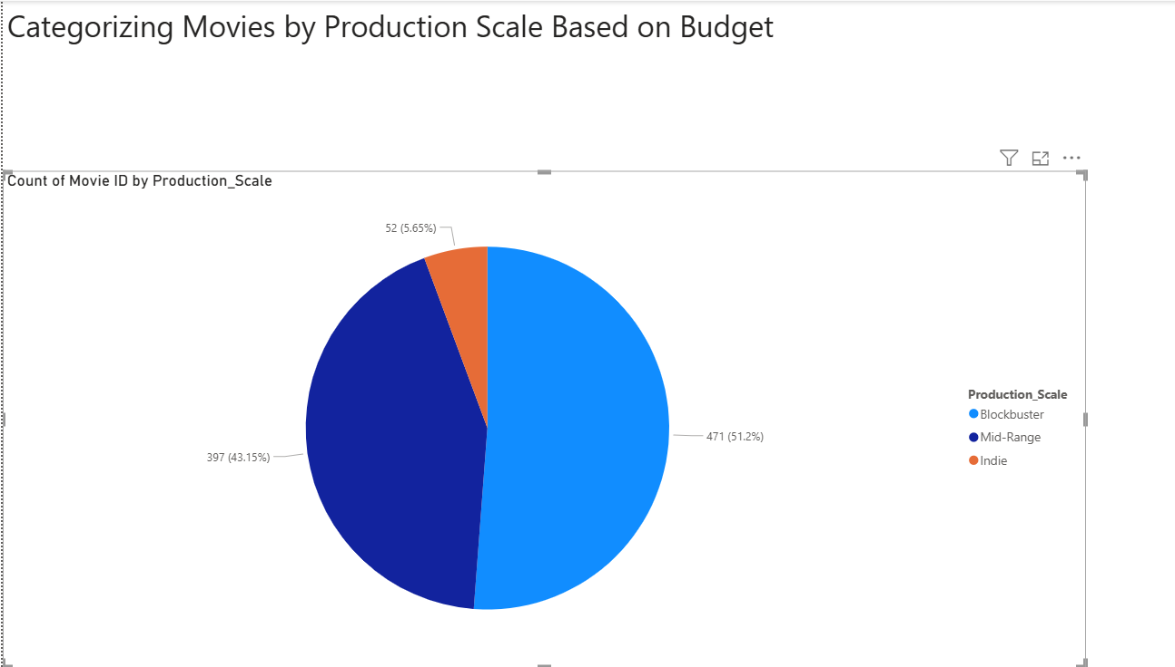
Insights: The distribution shows that Blockbuster films dominate production (51%), indicating strong industry focus on large-budget projects due to their higher commercial potential. Mid-range movies form 43%, suggesting they remain a common and financially safer strategy for studios. Meanwhile, Indie films account for only 6%, reflecting limited investment in smaller productions and challenges in market reach. Overall, the industry prioritizes higher-budget filmmaking for competitive box office success.
2:Identifying Top 5 Most and Least Profitable Movies
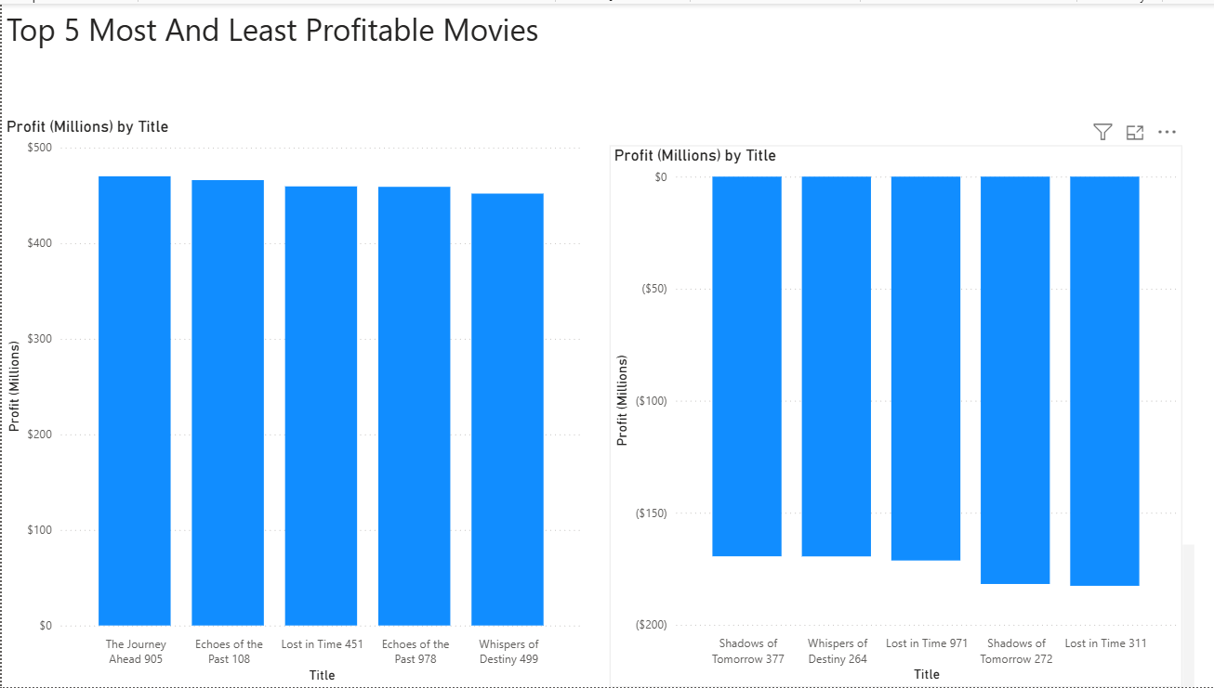
Insights: The analysis reveals a significant profitability gap across movies. The top five highest-earning films generated profits close to $450M each, demonstrating that successful titles can deliver exceptionally strong financial returns. In contrast, the least profitable movies incurred losses nearing $150M, indicating that poor performance carries major financial risk. This contrast highlights that the movie industry operates in a high-reward yet high-risk environment, where strategic decision-making around budget allocation, genre choice, and marketing is crucial for commercial success.
3:Analysis Of Box Office Performance
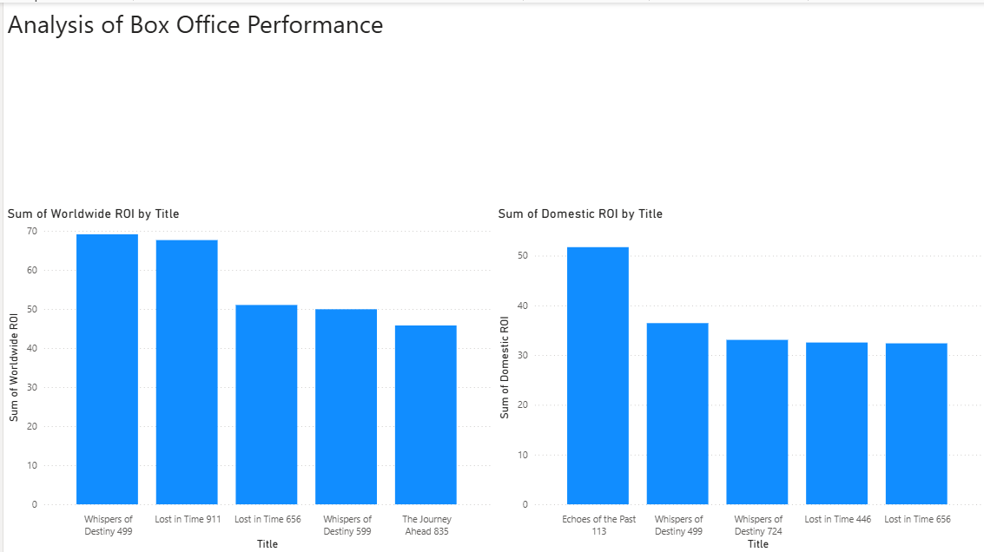
Insights: The Box Office performance analysis highlights a noticeable contrast between worldwide and domestic returns. Movies such as “Whispers of Destiny 499” and “Lost in Time 911” stand out with the highest worldwide ROI, indicating strong international acceptance and revenue generation beyond their home market. In comparison, domestic ROI is led by “Echoes of the Past 113,” suggesting localized popularity but limited global impact. Overall, the trend shows that while some movies achieve moderate domestic performance, global audiences play a critical role in pushing profitability, emphasizing the importance of international distribution, global marketing campaigns, and cross-cultural genre appeal.
4: Director's Impact on Revenue
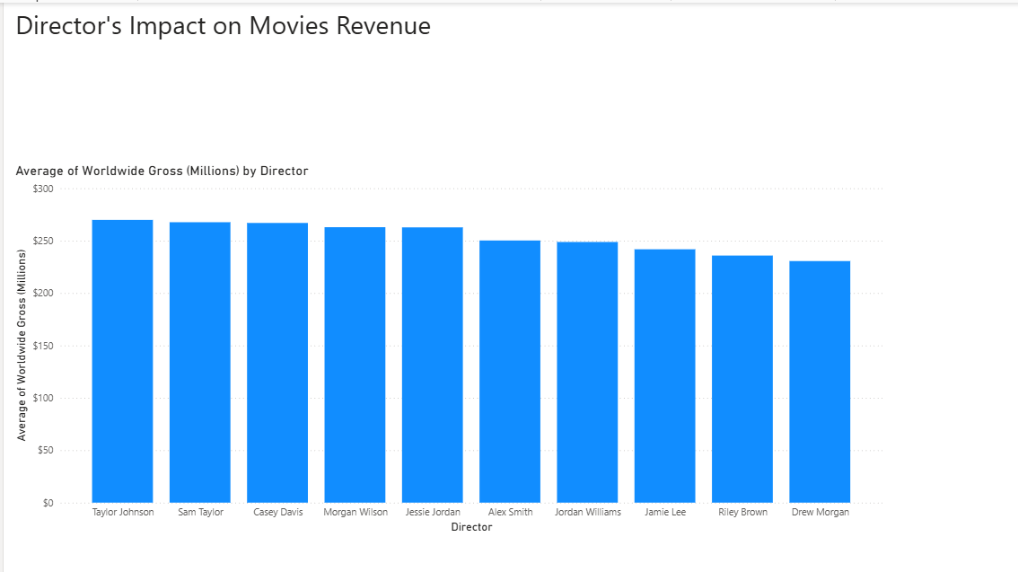
Insights: The analysis reveals that a director’s influence plays a significant role in shaping box office outcomes. Taylor Johnson, Sam Taylor, and Casey Davis lead the rankings with the highest average worldwide gross revenues, consistently delivering films that perform strongly on a global scale. This suggests a strong alignment between their filmmaking style, audience expectations, and possibly established brand recognition. On the other end, directors like Riley Brown and Drew Morgan generate comparatively lower global revenue, indicating either niche audience reach or limited commercial appeal. Overall, the trend shows that proven directorial reputation contributes directly to box office success, making director selection a strategic factor for maximizing movie revenue.
5: Budget and Revenue Correlation
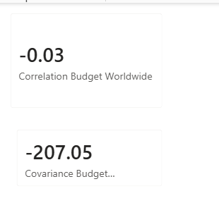
Insights: There is no relationship between Budget and Worldwide Gross.
6:Language Influence on Ratings
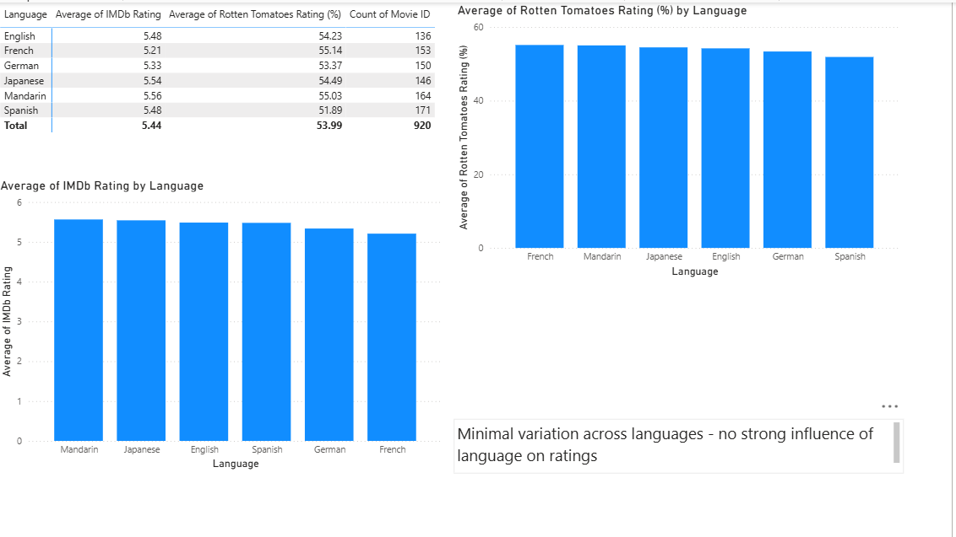
Insights: The analysis shows minimal variation in audience ratings across different languages, indicating that language does not significantly influence how movies are rated by viewers or critics. IMDb and Rotten Tomatoes averages remain closely aligned, with Mandarin and Japanese films performing slightly above others, while English, Spanish, and German titles follow closely behind. The narrow rating range suggests that content quality, storytelling, and execution have a greater impact on audience perception than language itself, demonstrating that well-produced films are capable of resonating with global audiences regardless of the language they are delivered in.
7:Filming Location and Box Office Success
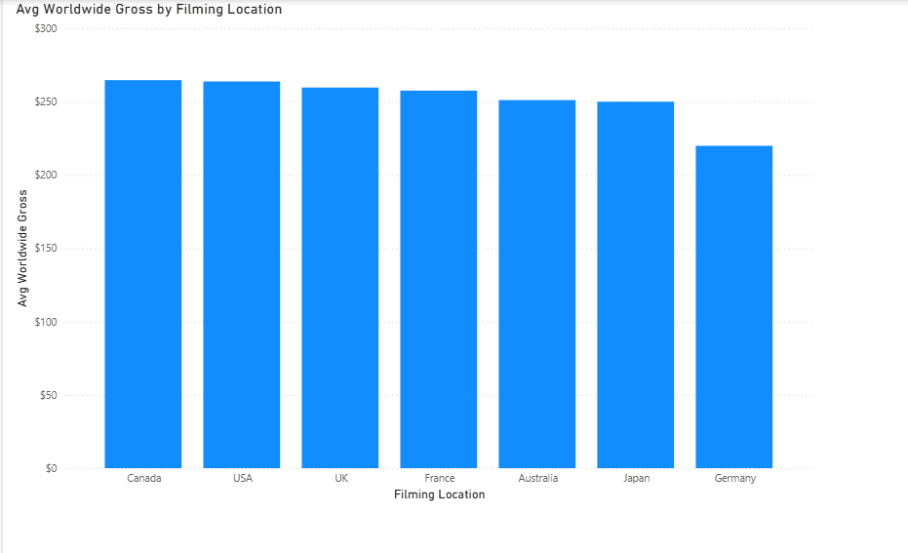
Insights: The analysis shows that movies filmed in Canada and the USA generate the highest average worldwide gross, slightly outperforming those filmed in the UK and France. Meanwhile, Germany records the lowest average earnings, indicating a weaker commercial performance compared to other major filming regions. The narrow difference among most countries suggests that filming location alone is not a major determinant of box office success, though locations like Canada and the USA may provide better infrastructure, production incentives, or global market appeal that contribute to stronger earnings. This insight highlights that while location can offer advantages, success still largely depends on movie quality, cast, direction, and marketing.
8:Genre Popularity Over Time
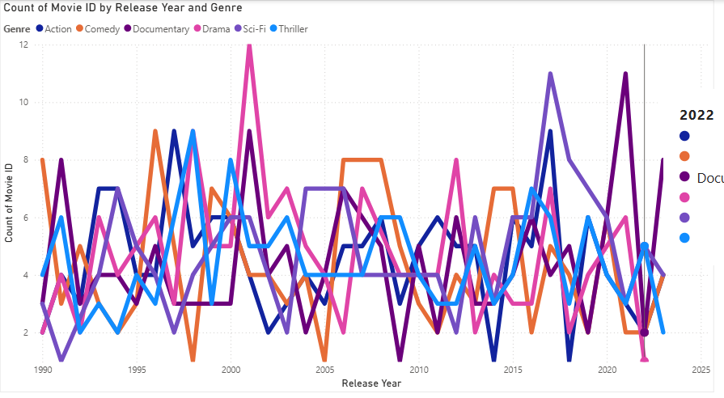
Insights: The trend analysis shows that movie production has remained consistently active across all major genres, but with noticeable peaks at different times. Drama and Thriller genres show the most fluctuation, indicating periodic surges in audience interest, particularly around the early 2000s and post-2015. Documentaries display a slower but steadily rising production trend, suggesting growing audience demand for real-story content. Meanwhile, Action and Sci-Fi remain relatively stable with moderate production counts every year, showing they are consistent but less volatile genres. Overall, the data suggests that while genre demand shifts with time, no single genre dominates continuously, highlighting the industry’s dynamic response to changing audience preferences and cultural trends.
9: Release Month Impact on Revenue
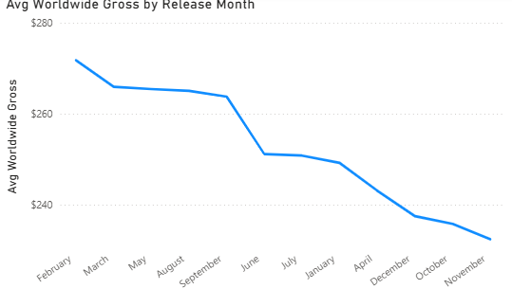
Insights: The analysis reveals that release timing plays a significant role in box office performance. Movies released between February and September consistently achieve higher average worldwide gross, peaking in February at nearly $275M. However, films released from October to December show a noticeable decline, with November recording the lowest revenue, suggesting that late-year releases may face stronger competition, lower audience turnout, or limited screening windows. This trend highlights that early-year and mid-year releases are more financially advantageous, making release month a strategic factor for maximizing box office success.

10: Production Company Analysis
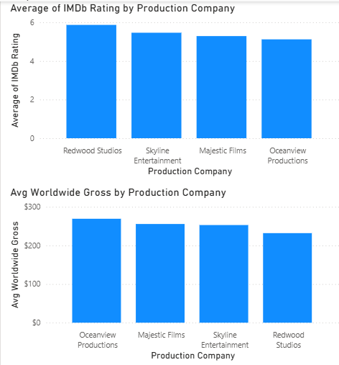
Insights: The comparison between production companies highlights a clear disconnect between audience ratings and box office revenue. Redwood Studios leads with the highest average IMDb rating, indicating strong audience appreciation, yet it records the lowest worldwide gross, suggesting limited market reach or lower commercial scale. In contrast, Oceanview Productions generates the highest average worldwide gross, outperforming competitors financially, despite having the lowest IMDb rating among the four companies. Majestic Films and Skyline Entertainment show balanced performance, with both stable ratings and revenue. These findings reveal that high audience ratings do not necessarily translate into highest commercial revenue, emphasizing that brand visibility, distribution strength, and marketing budget may be more influential drivers of box-office success than ratings alone.
11: Runtime and Rating Relation
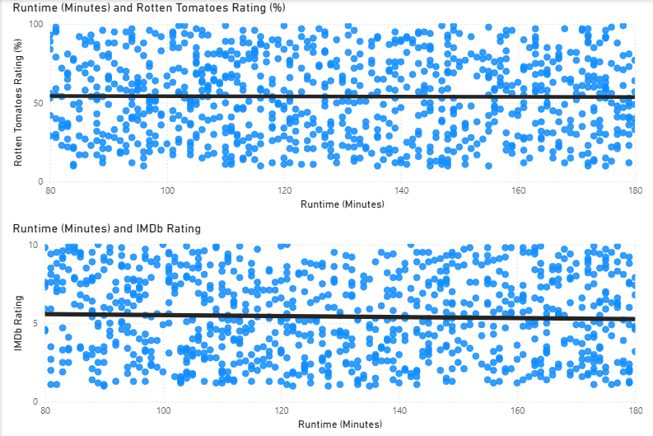
Insights: The scatter plots reveal no strong correlation between movie runtime and audience ratings, either on Rotten Tomatoes or IMDb. Movies across all runtime ranges—from 90 minutes to nearly 180 minutes—show a wide spread of ratings, indicating that longer movies do not guarantee higher appreciation, nor do shorter movies imply lower reception. While there are a few high-rated outliers with longer runtimes, the trendline remains almost flat, confirming that rating outcomes are driven more by content quality, storytelling, and genre than by the duration of the movie. This suggests that production studios should focus on narrative value rather than extending runtime for perceived audience impact.
12:Comparative Analysis of MPAA Ratings
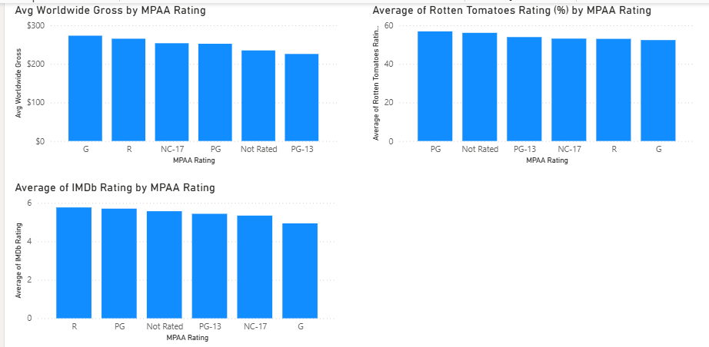
Insights: The analysis highlights noticeable performance differences across MPAA categories. G-rated movies generate the highest average worldwide gross, indicating strong family-audience appeal and wider market accessibility. R-rated and NC-17 movies follow with strong revenues but slightly lower audience acceptance, likely due to restricted viewer segments. In terms of audience perception, PG and Not-Rated movies receive the highest Rotten Tomatoes ratings, while IMDb ratings remain relatively stable, with only a slight decline for G and NC-17 films. Overall, the data suggests that while family-friendly movies dominate commercial performance, critically favored movies emerge more often from PG and Not-Rated categories, reflecting that creative or indie-style storytelling (typically Not Rated) may resonate more with critics even if not always achieving the same box-office scale.
13: Trends in Movie Releases
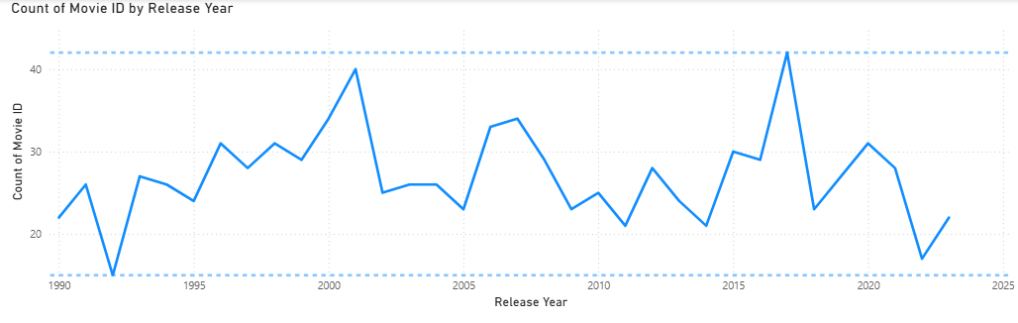
Insights:The trend shows a fluctuating yet steady volume of movie releases over the years, with noticeable peaks around 2001 and 2017, indicating phases of heightened production activity. Periodic declines, such as around 1992 and 2022, suggest industry slowdowns likely influenced by economic or external events. While the overall pattern shows moderate growth and recovery cycles, the data highlights that the movie industry operates in waves of expansion and contraction, reflecting changing market conditions, technological shifts, and evolving audience consumption behavior.
14: Performance Rating of Genres
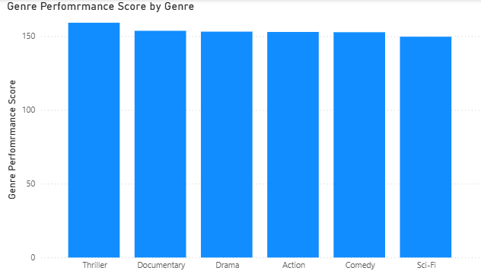
Insights: The results show that Thriller emerges as the highest-performing genre, closely followed by Documentary and Drama, indicating strong audience engagement and consistent critical reception across these categories. Action and Comedy maintain competitive performance, reflecting their broad commercial appeal but slightly lower rating strength. Sci-Fi ranks at the bottom among the evaluated genres, suggesting that although it may attract niche audiences, its return and rating quality are comparatively lower. Overall, the analysis highlights that story-driven genres such as Thriller and Documentary outperform spectacle-based genres, emphasizing the growing importance of narrative depth and realism in audience preferences.

15: Advanced DAX: Profitability Analysis
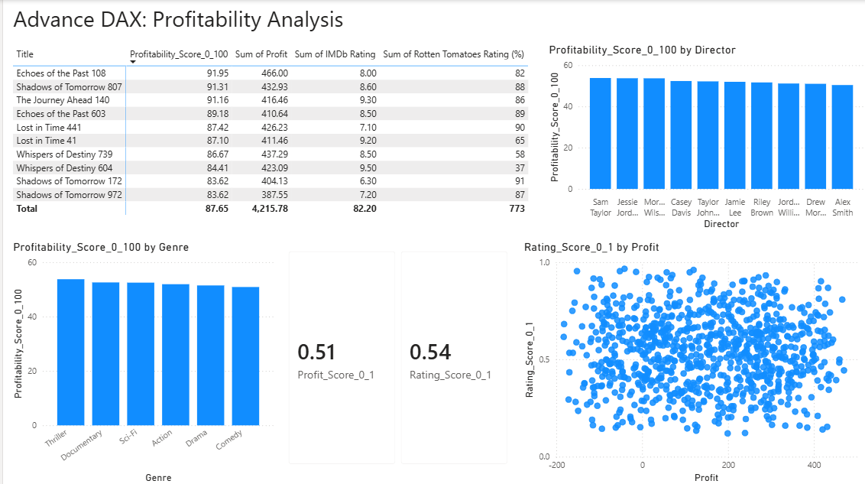
Insights: The profitability scoring model, which combines revenue and audience sentiment, highlights “Echoes of the Past” and “Shadows of Tomorrow” as the highest‐ranked movies with profitability scores exceeding 91, demonstrating strong financial returns supported by solid rating performance. When analyzing profitability by director, results show consistent mid-range profitability scores across all directors, suggesting that profitability is influenced more by project characteristics than individual directing style. Genre-wise, Thriller and Documentary deliver the strongest profitability, reflecting a balance of controlled budgets and favorable rating outcomes. The scatter plot comparing profit and rating score confirms a weak positive relationship, indicating that higher audience ratings do not always guarantee higher profitability. Overall, the profitability analysis reveals that successful movies perform well when financial discipline aligns with positive viewer perception, rather than relying solely on genre or director reputation.
16: Language Diversity in Films
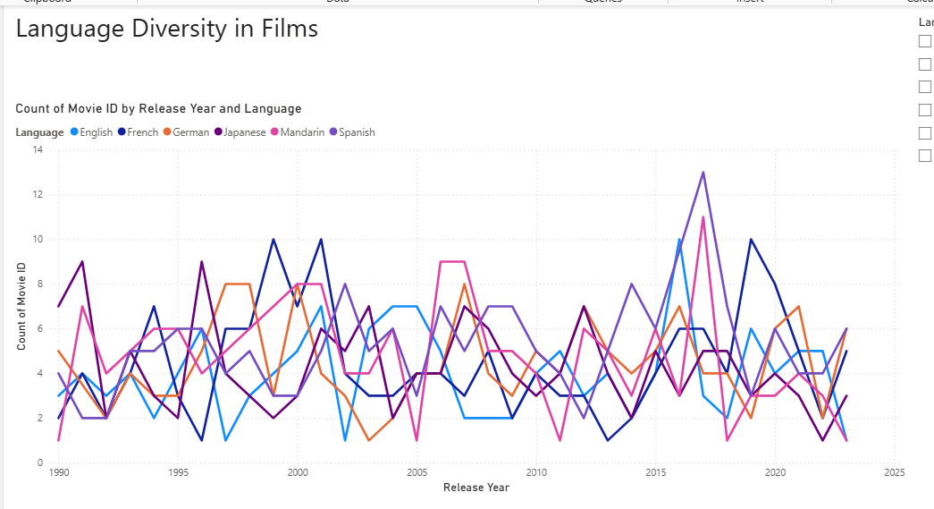
Insights: The trend shows a consistent presence of multilingual movie production over the years, with no single language dominating dramatically, reflecting a broadly diverse and inclusive film landscape. Occasional peaks, such as increases in Mandarin and English productions around 2017, indicate targeted market expansion during certain periods. The relatively balanced contributions across French, German, Japanese, and Spanish demonstrate that the industry is not centralized to a single linguistic audience but is adapting to global demand. Overall, the data highlights that language diversity has become a stable pattern in film release trends, supporting the growth of international storytelling and cross-cultural cinema consumption.
17: Data Modeling: Time Series Forecasting of Genre Popularity
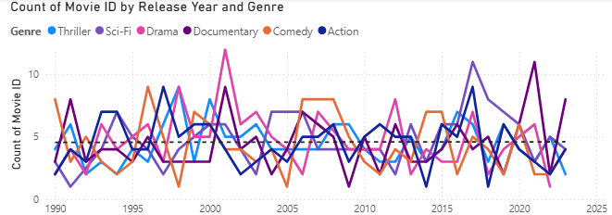
Insights: The long-term trend reveals that genre popularity is cyclical rather than linear, with each category experiencing alternating phases of rise and decline. Thriller and Documentary films show notable peaks around 2000 and 2017, indicating periodic resurgence driven by audience interest in suspense and real-world narratives. Comedy and Drama maintain moderate but steady production levels, suggesting they remain stable, low-risk formats for filmmakers. The comparatively sharper fluctuations in Sci-Fi reflect its dependence on technological attractiveness and budget availability, making it a more investment-sensitive genre. Overall, forecasting indicates that Thriller and Documentary genres are positioned for periodic high-demand waves, while Comedy and Drama sustain consistent baseline popularity, serving as dependable production segments over time.
18: Advanced Data Transformation: Identifying Trendsetting Movies
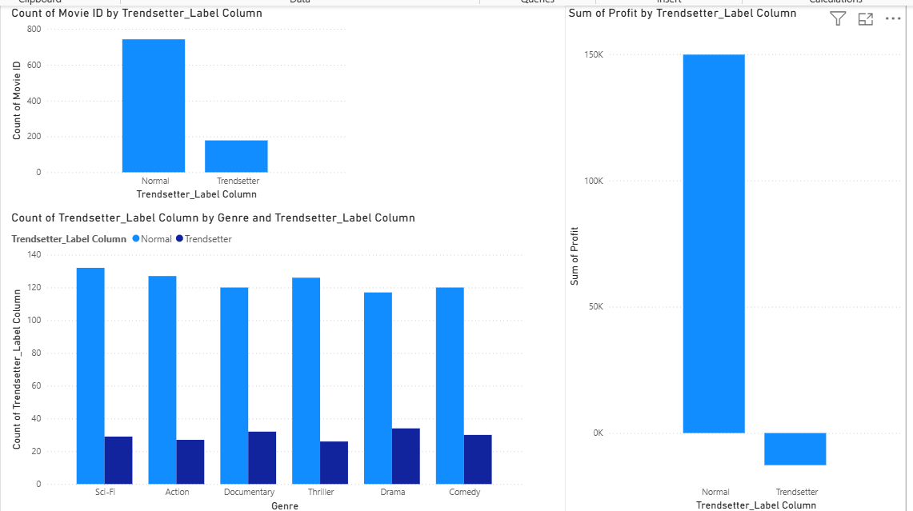
Insights: The analysis highlights that while only a small portion of films qualify as Trendsetters, they represent a distinct category of content attempting new themes, genres, or unconventional storytelling. Trendsetter films appear consistently across all major genres, indicating that innovation is not genre-dependent. However, the profit comparison reveals a crucial insight — although Trendsetters strive to shape future audience preferences, they generally experience lower profitability than mainstream films, suggesting higher creative risk and delayed or uncertain commercial returns. This implies that trendsetting efforts may serve more as long-term brand value and innovation drivers rather than immediate revenue generators, making them an essential yet strategically sensitive component of a studio’s portfolio.

SECTION 3: Dashboard Creation

3.1 Financial Analysis Page
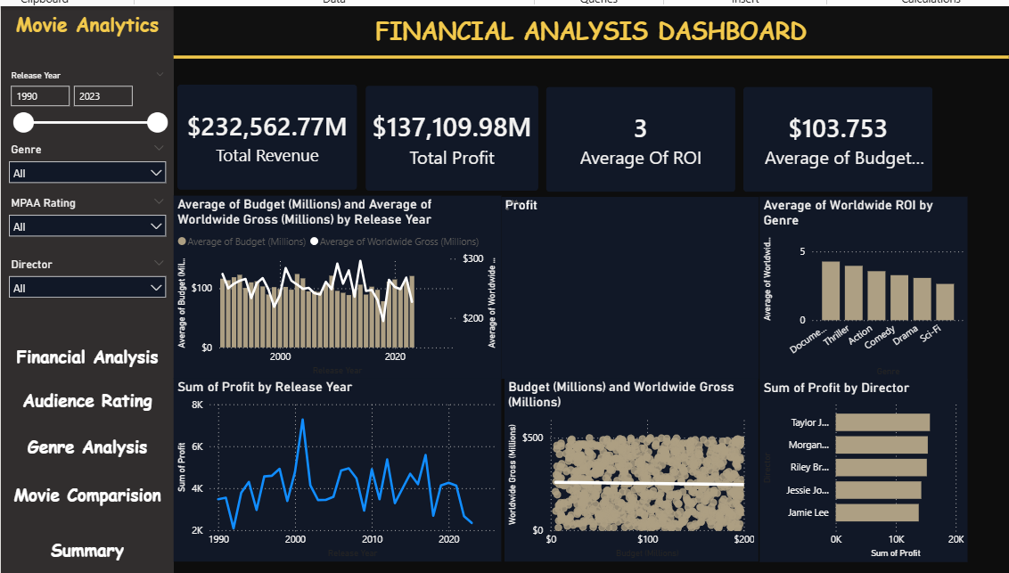

3.2 Audience/Critics Rating Analysis Page
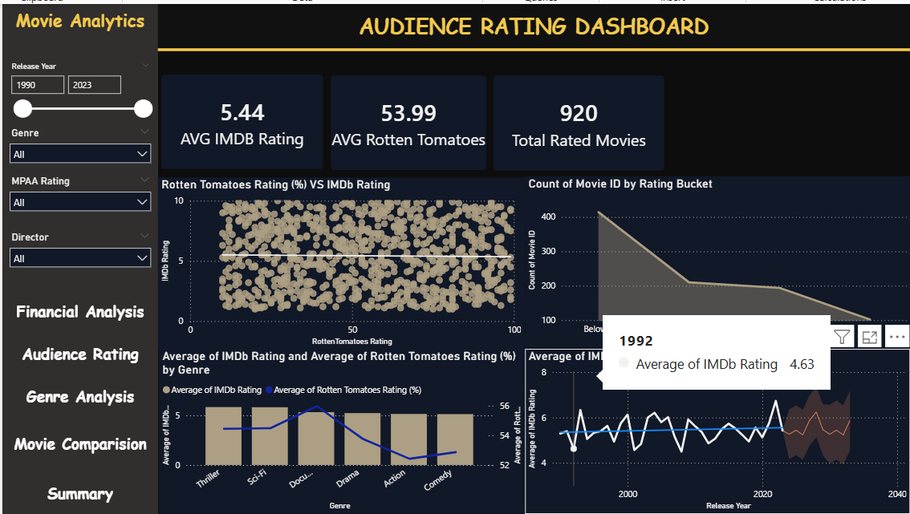

3.3 Genre Analysis Page
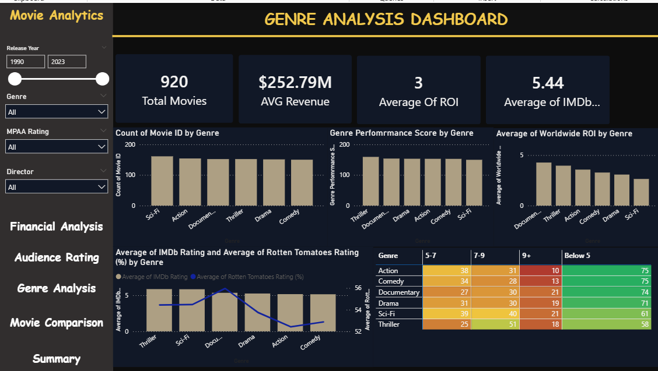

3.4 Movie Comparison Page
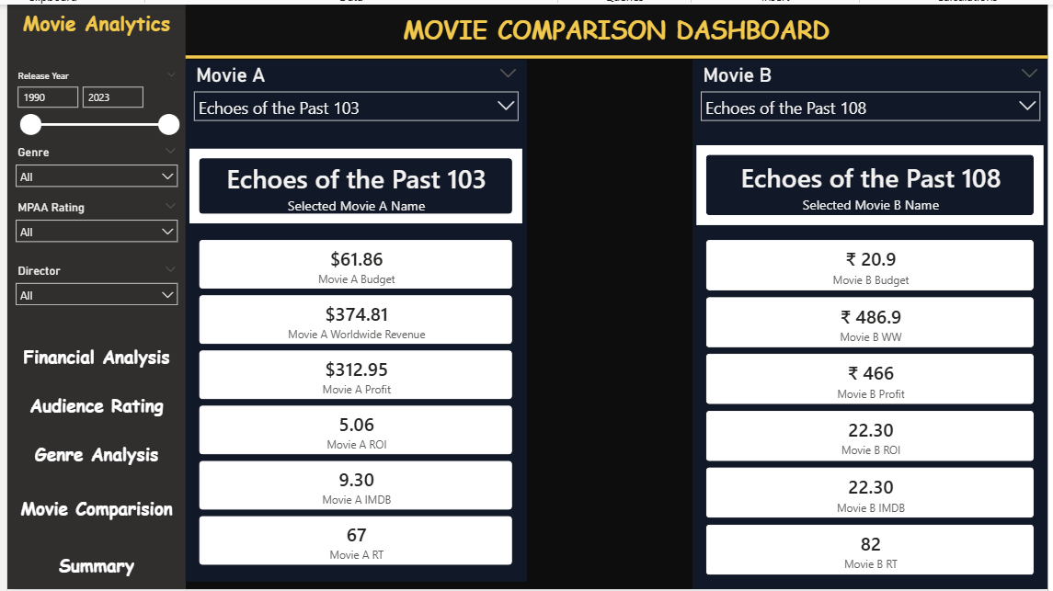

3.5 Summary
